
EX1

Main Colors:
Red – Yellow – Orange - White
Color Scheme:
Analogous / warm color


EX2
Color Palette:
- Deep Rust (Black)
- Golden Amber
- Orange
- Dark Brown

Psychological Effects:
- Warmth & Comfort:
- Elegance & Purity:
- Nostalgia & Reflection:
- peace and uncertainty.

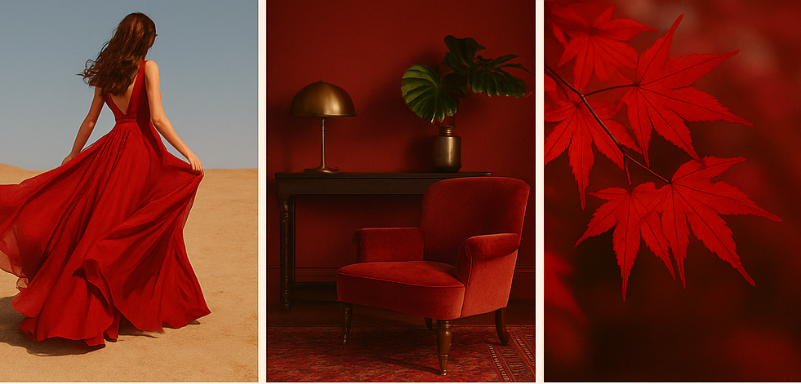
EX3
feelings of passion, power, intensity, and warmth. It stimulates energy and excitement. N maybe sth like elegance idk.

Bonus:
The “Color Constancy” Illusion
- What it is:
A viral photo of a dress where some people see blue and black, while others see white and gold.
- Why it happens:
This illusion is based on color constancy the brain tries to correct for lighting conditions. Depending on whether your brain assumes the dress is in shadow or light, you’ll perceive completely different colors.

Song Named After a Color:
"Red" – by Taylor Swift
- Why “Red”?
Taylor uses red to symbolize intense, chaotic, and passionate emotions.

